We modeled a real-time notification system for a community events app. Our goals were to support simultaneous registrations, instant notifications, simple AI suggestions, and safe logging.
Design choices
We used Observer for real-time subscriptions, Factory to create notification objects (Push/Email/SMS), and Singleton for Event-Manager as the single source of truth. For concurrency we recommend optimistic locking with a version field and optional Redis counters for performance.
A user registers → Event-Manager checks capacity → reserves atomically → Notification-Factory creates a confirmation which is sent asynchronously → AI-Suggester suggests similar events → Admin-Logger records the action. If the event is full, users receive an 'event full' notification instantly.
Trade-offs & reflection
We chose Observer because notifying multiple users when an event changes is naturally a one-to-many problem; it fits cleanly with Web-Socket/SSE subscriptions. The Factory pattern decouples notification creation from sending logic so we can extend delivery channels without changing business logic. Singleton for Event-Manager simplifies the mental model there is one authoritative manager that coordinates checks and notifications.
Trade-offs: this design keeps the system simple to understand and extend, but places more responsibility on Event-Manager (risking a bottleneck). To avoid that in production we would split responsibilities across micro-services (e.g., Event Service, Notification Service) and use queues for durability and throughput. We also prioritized optimistic locking which favors throughput and simplicity, but requires retry logic for edge-case collisions.
Ethical note: store minimal personal data, protect device tokens and emails, and provide users with options to opt out of notifications.
Trade-offs: simple and extensible but Event-Manager can become a bottleneck at scale; we suggested queuing and micro-services as scaling strategies. Any questions?

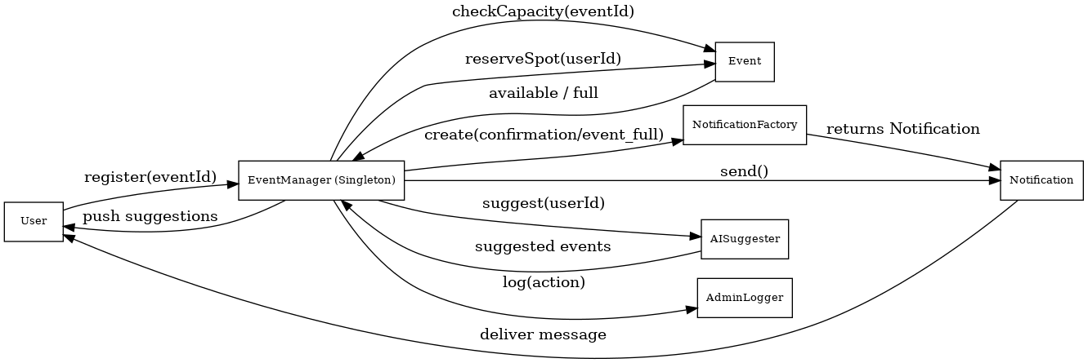
SEQUENCE DIAGRAM

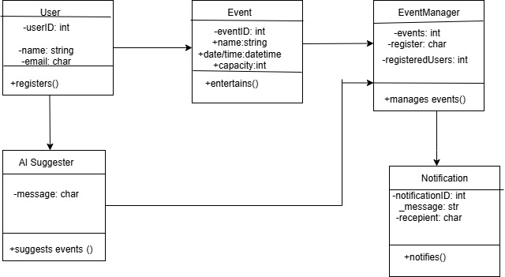
CLASS DIAGRAM

